Drama Lesson Portfolio
06/15/2020
ECHE 3325 Section 01
Grade level: 2nd grade
Theme: Life cycle
Title: The Wonderful Life Cycle of Butterflies

TEKS:

Science TEK: §112.13. Science

- (10) Organisms and environments. The student knows that organisms resemble their parents and have structures and processes that help them survive within their environments. The student is expected to: (A) observe, record, and compare how the physical characteristics and behaviors of animals help them meet their basic needs;(B) observe, record, and compare how the physical characteristics of plants help them meet their basic needs such as stems carry water throughout the plant; and (C) investigate and record some of the unique stages that insects such as grasshoppers and butterflies undergo during their life cycle.

Art TEK: §117.107. Theatre
- (1) Foundations: inquiry and understanding. The student develops concepts about self, human relationships, and the environment using elements of drama and conventions of theatre. The student is expected to: (A) develop confidence and self-awareness through dramatic play; (B) develop spatial awareness in dramatic play using expressive and rhythmic movement; (C) imitate actions and sounds; and (D) imitate and create animate and inanimate objects in dramatic play.

CD:
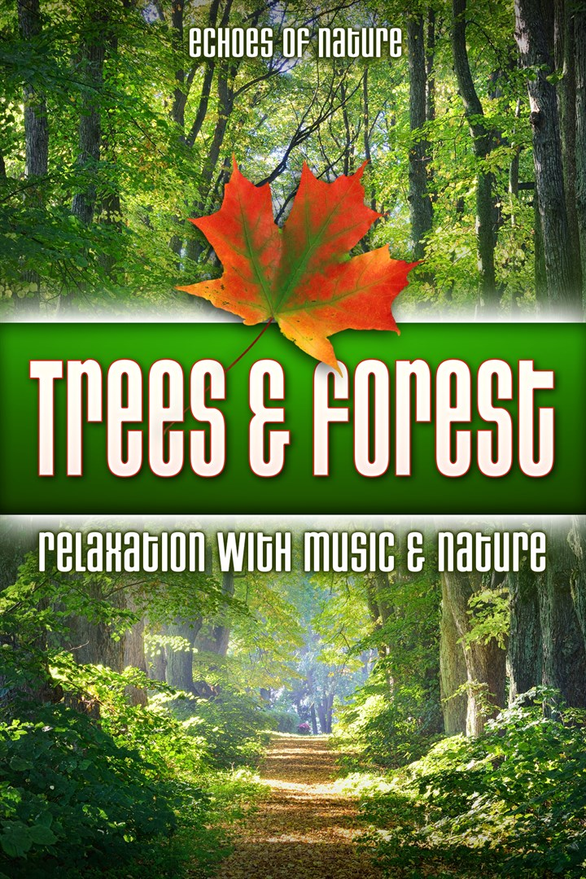

The CD I choose to implement into my drama lesson is “Trees & Forest Relaxation with Music & Nature”, by Liam Dale. By having this CD, I would play this as background music when we are interacting in the movement activity. This CD has 120 minutes of pure nature sounds, so the students can listen to the calming sounds as we are creating the movement of the life cycle.

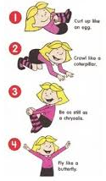
Movement:
- Curl up like an egg
- Crawl like a caterpillar
- Be as still as a chrysalis
- Fly like a butterfly

3325 Lesson Cycle Template

Connection to previous learning, life, literature, etc | I will gather my students on the large group rug, and begin to say, “Who is excited to pretend to make the movements of the butterfly life cycle?”.  I will say, “Who remembers the stages of the butterfly life cycle that we learned about this week?”. “How might we be creating those stages with our body?”. Once, they answer, I will ask them to demonstrate what it might look like at each stage of the butterfly life cycle. Then I will explain to my students that they will be able to create the movements of the full life cycle of a butterfly.
Teaching Point | Today we will be reviewing the life cycle of the butterfly. We will be creating the movement of the four-stage life cycle of butterflies with our whole body.
Teach | Listen to me as I explain to what we are going to be doing.  First, we are going to review the stages of the life cycle of a butterfly.  Then I will ask, “What is the first stage?”. Once students have said egg, I will demonstrate.  Then, we will start with the first stage of the life cycle. I will demonstrate by curling myself into a ball on the floor. Students will follow along after I have demonstrated the first stage. I will then say, “What is the next stage?”. Once students have said caterpillar I will move on.  Then, I will move to the second stage of the life cycle by getting on all fours and crawling around like I am a caterpillar. Students will follow along after I have demonstrated the second stage. I will then say, “What is the third stage?”. Once students have said chrysalis, I will move on.  Then, I will sit on my bottom, or wrap myself in a blanket to show the third stage of the life cycle. Students will follow along after I have demonstrated the third stage. I will then say, “Alright class, finally what is the fourth stage?”. Once students have said butterfly, I will move on.  Lastly, I will stand up, and flap my arms (wings), or use my blanket as wings to show that I am flying like a butterfly.  Finally, I will explain to my students, when I turn on the “Trees & Forest” CD, they will have the time to go through the life cycle. They must first go through the cycle in order, and then once they have gone through it once in order, they can go through the different stages as they please. I will also tell them that if they have another movement that represents a stage in the life cycle they can do that once they have recreated the movement I showed them.
Active Engagement | Now it’s your turn to try it out.  Once the music is playing, I will dismiss the students will find a spot in the classroom that they will have enough room to move about.  They will start at stage one of the life cycle and move on to the next once they completed the previous stage. Students may go at they own pace to the music.  Once they have completed life cycle, they can start to create their own movements for the stages, or they can stay at the stage of their liking. I will be interacting with the students, and monitor to help those students who need guidance.
Link to future learning/Check for understanding | Today we reviewed the four-stage life cycle of the butterfly, and how we can create whole body actions to imitate what it looks like at each stage. I will ask students questions to assess their understanding about the life cycle, and ask students if they were able to create new movements on their own. If so I will give the students the opportunity to show us the new action they created.


Visiting Artist: Shara Phillips

Shara Phillips is an instructor here at the local Conroe, and Montgomery Back Stage Dance studio. You can contact the studio at (936)-582-2970. Ms. Phillips has been studying dance since she was three years old. She has trained in a variety of dance from ballet, pointe, jazz, modern, contemporary, and lyrical. She received her Bachelor of Fine Arts degree in dance from Sam Houston State University. She spent four years with a profession contemporary dance company, where she was a dancer and a choreographer. Phillips has been teaching dance for over seventeen years. I will email her at Cindy@backstagedancestudio.net to ask her to join me for this lesson. I will explain to her that my students will be imitating the stages of the butterfly through movement. With her knowledge of dance, I believe she will be a perfect fit to come into my classroom to help students with their whole-body movement. She will be teaching my students to skill of imitating by watching as her an I create the movements.

Floorplan:
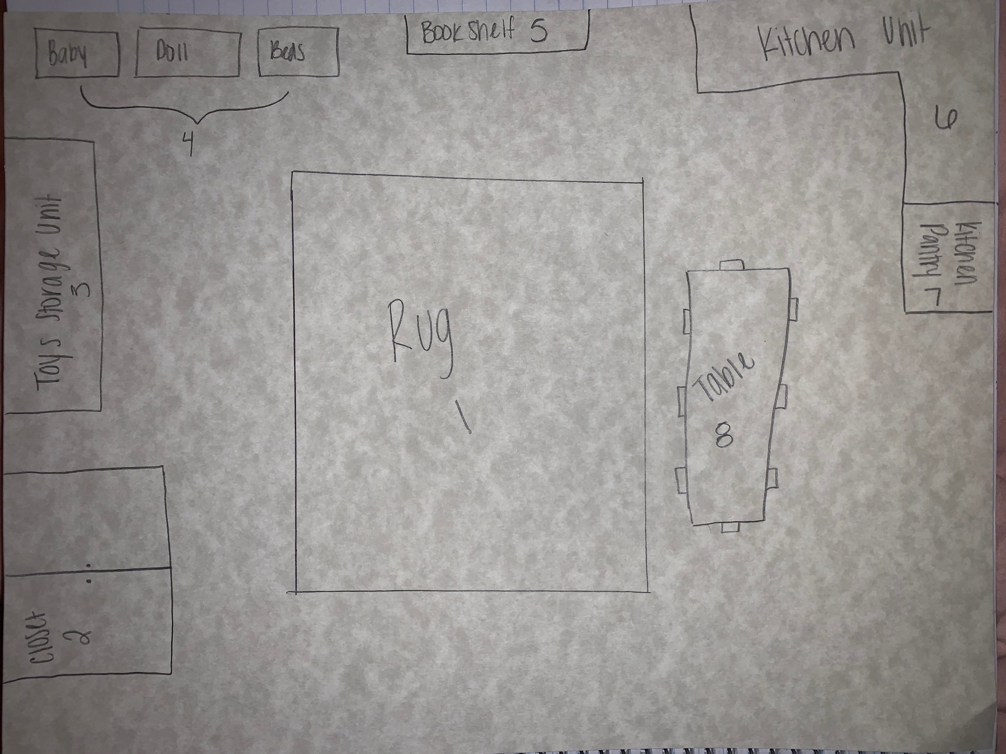
- Rug. Here students can gather and collaborate when they are in the dramatic play center.
- Closet. This closet will be filled with a variety of dress up outfits that students can choose from when playing in this center. They will have a collection of shoes as well.
- Toy storage unit. This is where toys such as baby dolls, purses, cameras, sunglasses, etc. to play with in this center.
- Baby doll beds. This is where a collection of baby dolls will be placed. Those who choose to play with the baby dolls, can put their babies to rest in these beds.
- Book shelf. This book shelf will hold books such as cook books. The students will be able to imitate the recipes that are in the book to create dishes.
- Kitchen unit. This will allow students to collaborate and work with other students to play in the pretend kitchen. They can use this as playing pretend house.
- Kitchen pantry. Here will hold a variety of play kitchen food, and utensils.
- Table. This is where students can gather around to eat the foods they create in the kitchen, or work together to create dramatic play.
Purpose of this center:
The purpose of this center, if for students to explore different roles and situations as they play with the variety of materials provided to them. Students will be able to use their imagination with the materials within this center to create meaningful learning experiences. They become a role that is in everyday life such as a chef, and use the items in the center to act on that role. Through using their imagination, students will be able to collaborate with other students to take on certain roles.
Skills students will develop:
Students will learn the skills of creativity, curiosity, and collaboration. With this center, students can learn to be creative with the materials that are provide to them. With have a variety of materials within the center, this will spark their curiosity in how they will use the items. Lastly, collaboration. In this center, students will be able to work with others to play with the materials provided to them. Students can come together to pretend play “House”. They will have to collaborate with each other on who will take on what role, and the rules within their playing.
Basic materials needed for the center:
Baby dolls, play kitchen (food, forks, spoons, plates, bowls, pots, pans), table, cook books, phone book, house phone, rug, dress up clothes, shoes, baby doll beds, purses, sunglasses, and cameras.

Guidelines:
- Students will respect the materials provided to them.
- Students will respect the teacher’s rules.
- Students will respect the visiting performer.
- Students will not play rough with any of the center items.
- Students will place all items used back into their proper home within the center.
Assessment:
To assess my students for this lesson, I will be monitoring my students to see if they ran through the four-stage life cycle of the butterfly with the demonstration I showed them. I want my students to be able to follow my actions and be able to imitate them I play the CD. During the lesson, I can ask students more formative questions such as, “What are the four stages of the butterfly?”, “Who can show me the first stage using their body?”, “Who can show me the second stage using their body?”, etc.
Points | 4 | 3 | 2 | 1
Imitated all stages of the life cycle. | Imitated the four stages of the butterfly. | Imitated three stages of the butterfly. | Imitated two stages of the butterfly. | Imitated one stage of the butterfly.
Extra points: |  |  |  | Created their own new movement for one stage.
Extra points: |  |  |  | Put away all props used in the center.

